**Author: Asrar Syed**

**Class: CSC 3210**

**Assignment #2**

**lastname01.asm**

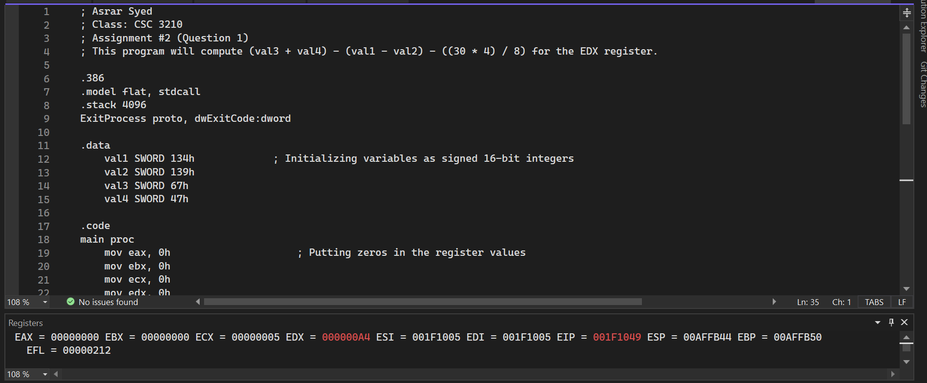

**lastname02.asm**

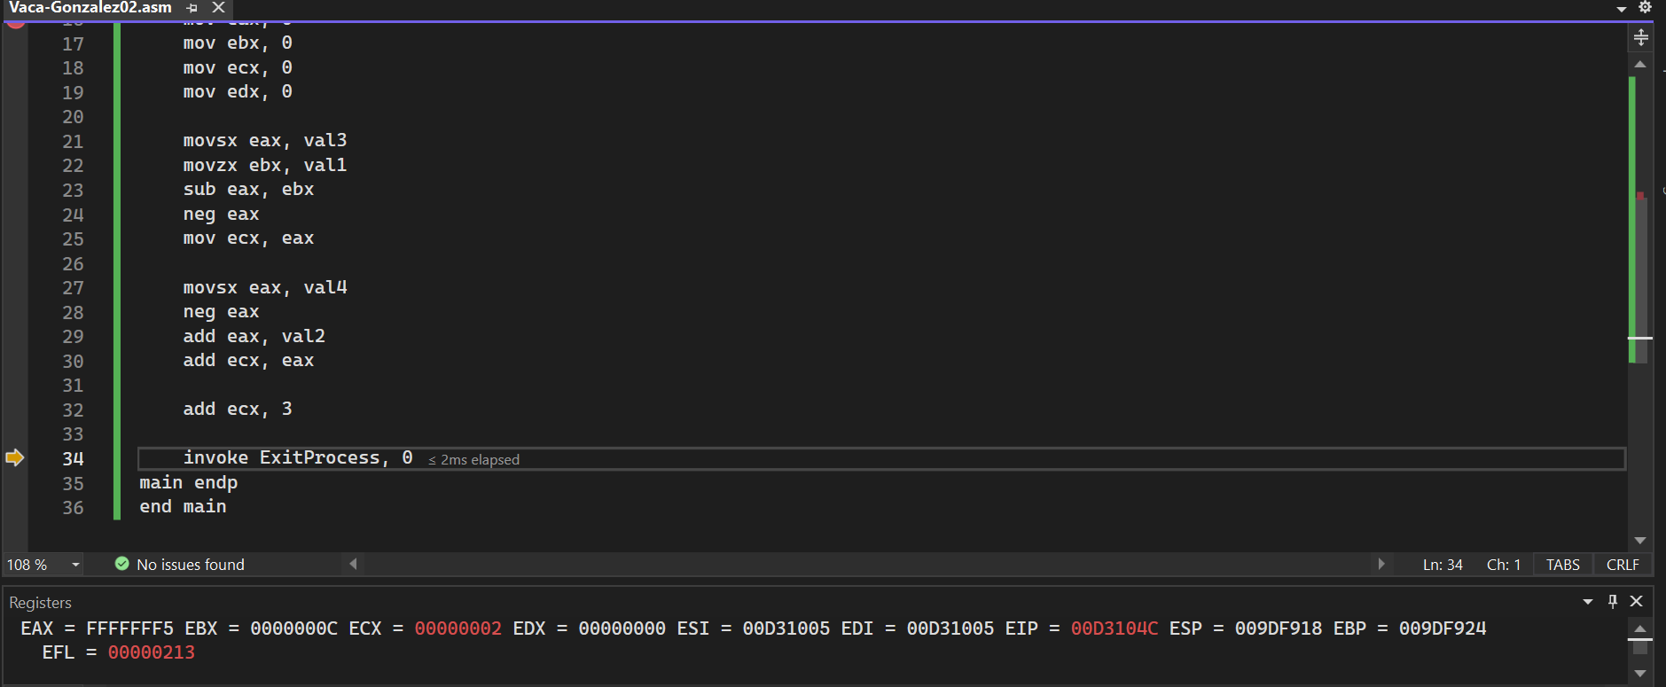

**lastname03.asm**

